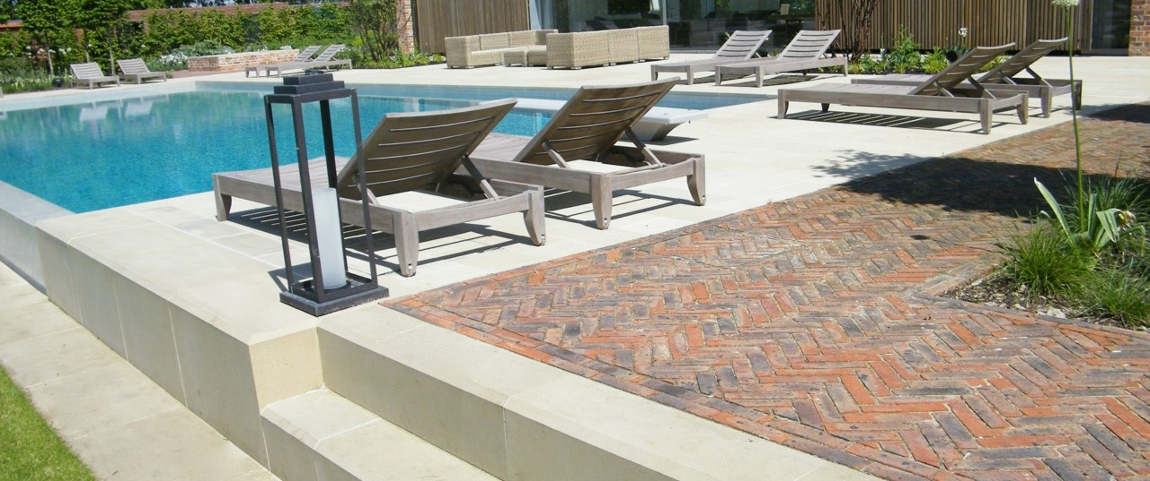

Picture banner at top, taken from portfolio page and cropped

THE BUILD

Once the design is complete, we will provide you with a full itemised quotation giving a complete breakdown of costs to build your garden.
We will arrange to meet you at our trusted supplier’s show sites to go through options for materials such as paving, pavers, bricks etc.
Once you are happy with the quotation the work will be booked into our schedule.
We operate five landscaping teams delivering the build projects, all of our staff are full time employed. We do not sub-contract any of our work and the same team will be on the project from start to completion.
We are hugely experienced in all the different aspects of a garden build whether it be a pond, oak pergola or building a brick or stone wall. Each same team has the necessary skills and training to complete the task to the highest standard.

Images of the build team

https://1drv.ms/a/s!AoOzUmJ6xCiNknlB1UF0JuuIFL8c

APL LOGO HERE ( can you make sure it is a link )

We are full members of the Association of Professional Landscapers.
By choosing an APL member it provides homeowners with a greater assurance when selecting a Garden Design and Build company. As a customer, you can feel confident that the APL landscaper you have chosen has met prescribed professional standards. By choosing wisely, you can ensure that you are never caught out by a rogue trader, and the quality and standard of work will be to the highest standard.

We have won multiple awards at National Landscaping awards for BALI, APL and Also Chelsea RHS show with a Gold medal back in 2011.
Then can you add the list of awards from the current website but quite small boxes not as big as previously as a banner to the bottom of the page.

