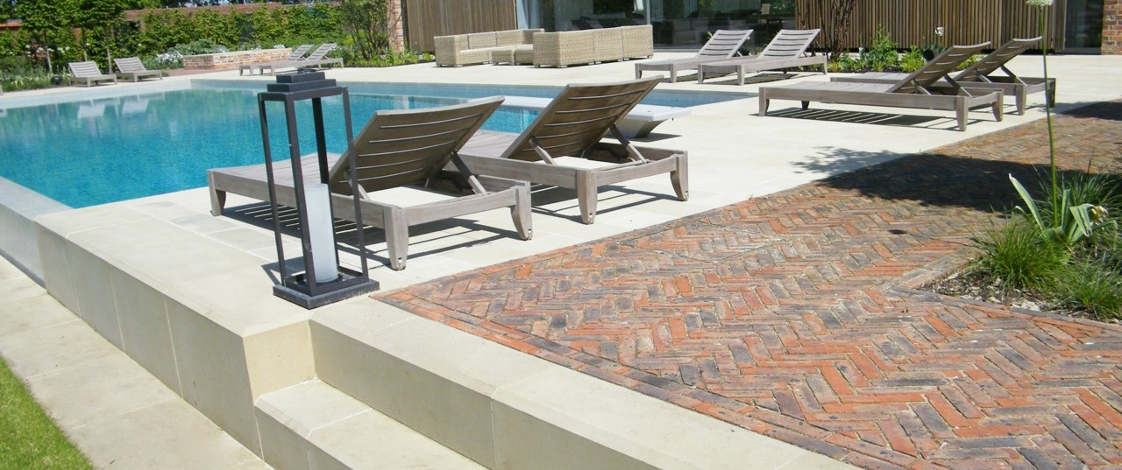

Picture banner at top, taken from portfolio page and cropped

THE BUILD

Once the design is complete, we will provide you with a full itemised quotation giving a complete breakdown of costs to build your garden.
We will arrange to meet you at our trusted supplier’s show sites to go through options for materials such as paving, pavers, bricks etc.
Once you are happy with the quotation the work will be booked into our schedule.
We operate five landscaping teams delivering the build projects, all of our staff are full time employed. We do not sub-contract any of our work and the same team will be on the project from start to completion.
We are hugely experienced in all the different aspects of a garden build whether it be a pond, oak pergola or building a brick or stone wall. Each same team has the necessary skills and training to complete the task to the highest standard.

Images of the build team

https://1drv.ms/a/s!AoOzUmJ6xCiNknlB1UF0JuuIFL8c

